|  |  |
| --- | --- |
| Assessment Title | Create a prototype |

## Competency Details

|  |  |
| --- | --- |
| Unit code/s and title/s | ICTPRG546 - Validate application designs against specifications |
| Qualification code/s and title/s | ICT50220 Diploma in Information Technology |
| Business unit/Work group | Business and Arts / IT Studies |

## Instructions

|  |  |
| --- | --- |
| Method/s of assessment | Questioning (Written)  Product (Written assignment)  Oral communication (Client Meeting) |
| Overview of assessment | This assessment will require you to:   * Complete written questions within this document. * Provide screen captures for written questions within this document. * Create a prototype for the study plan system according to design documentation * Demonstrate the prototype to the client and obtain feedback * Validate the prototype and complete the sign off procedure |
| Task/s to be assessed | This assessment will require you to complete the following tasks  Task 1 – Create a prototype  Task 2 – Demonstrate the prototype  Task 3 – Seek feedback and make changes  Task 4 – Validate the prototype |
| Time allowed | Refer to your schedule for submission dates |
| Location of assessment | Assessment can be completed anywhere with access to the resources required. (See Resources Required section below) |
| Decision making rules | To receive a satisfactory outcome for this assessment you must complete all parts correctly.  Word counts are provided as guidance only. |
| Assessment conditions | This assessment must be undertaken where conditions are typical of a work environment requiring cyber secure practices, processes, and procedures.  This is an unsupervised assessment, and you may access any required resources. |

|  |  |
| --- | --- |
| Resources required | To complete this assessment, you will require the following:  Software needed on class computers includes:   * Microsoft Windows * Microsoft Office * Invision Studio or Adobe XD or user interface development tool of choice * Microsoft Teams   The following documents will be required:   * ICTPRG546 - ASDS – SPS software requirements.   You can complete on your own computers or laptops if you are able to source the above requirements. |
| Result notification and reassessment information | You will be provided feedback and the result for your assignment on TAFESA Learn. You will be and given the chance to resubmit with required corrections only once.  Refer to the TAFE SA assessment policy for more information <https://www.tafesa.edu.au/apply-enrol/before-starting/student-policies/assessment> |

**SCENARIO**

You have been asked by ITWorks to complete a software project on a study plan system (SPS) for a client. The client currently has a system which does not meet all its needs. A software requirements specification document has been completed for the project and you will need to access this for information about what is required moving forward with the project.

**Create a Study Plan System prototype**

With a user interface development tool of your choice, create a prototype of the Study Plan System application to show the client. Base your application off the details in the software requirements specification document and your previous interview with the client. This prototype should be created from the perspective of a lecturer using the application.

This prototype does not need any code, it is just a prototype of the user interface.

**Meeting with the client about your prototype**

You are to organise a meeting with the client from the training provider that will be utilising the SPS application (Your Lecturer).  You can do this in the classroom, or in a Virtual Classroom. External students are to email their Lecturer to arrange a time to speak either over a Teams meeting, or phone.

In the meeting you will be showing them the prototype that you have created for the SPS application. The client will respond with feedback about your created prototype. You must demonstrate the intended use of your prototype and should show how you aim for your application to run in production.

You must request feedback from the client and will need to note any provided feedback in order to make future changes to your prototype. Using the Sprint Prototype Presentation Template, include the client feedback with your submission.

The meeting should take no longer than 10 minutes.

You must discuss with the client the requirements they have for the software application and any features that might be missing from the prototype.

Record this meeting and include with your submission documents.

**Prototype sign off**

You have finished demonstrating your prototype for the SPS application to your client in the previous task. You will need to write down some of the information and feedback that you discovered during this demonstration.

Follow the policy document, “ICTPRG546 - ASDS – Policy ID 191 - Rapid Application Development”, when completing the documentation below.

You **must fix the feedback** from the previously completed interview and explain how you have made those changes in your sign off document.

1. Complete the “ICTPRG546 - ASDS - IT_Works_Prototype_SignOff” document

Email your lecturer who is acting as your client with your completed sign off document. Provide the screen capture below of the reply from your lecturer indicating they sign off on the current project and documentation. Ensure that your email address is visible in your screen capture.

Screen capture of email and response:

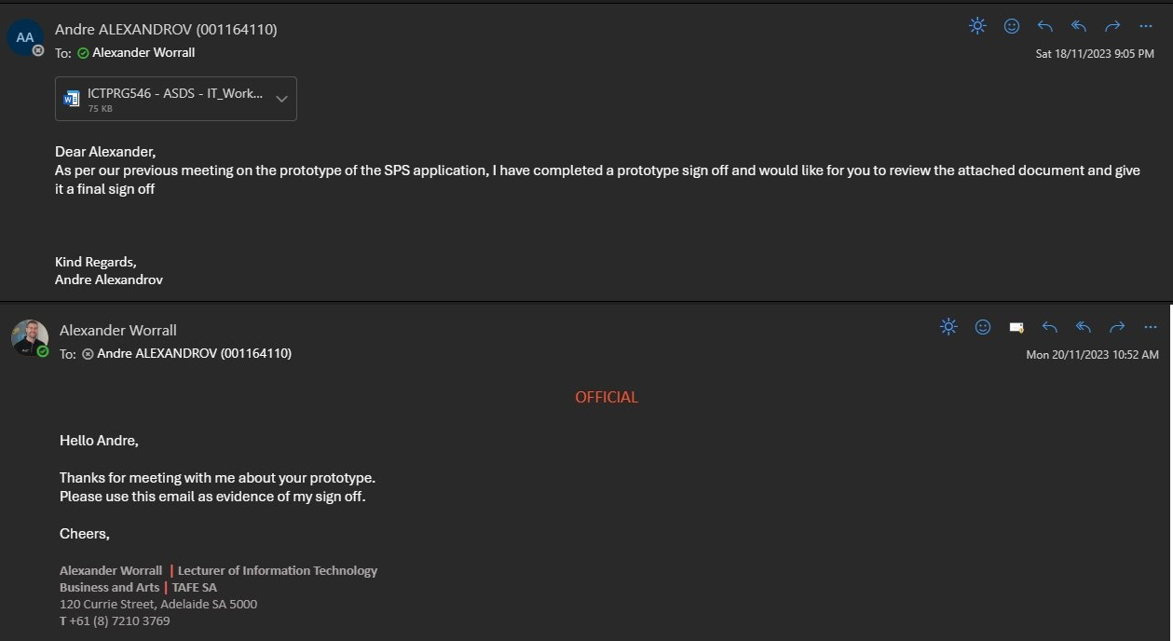

**Submission documents**

Include the following documents with your submission:

* Study plan system prototype adobe XD or Invision files
* Meeting recording
* Prototype signoff document
* Email of signoff from lecturer